**IBM Report (Nalaiya Thiran)**

**IOT based Smart Farming**

# SUBMITTED BY

**PHELIM CHERRYL MR (113219041082)**

PROPOSED SOLUTION FIT AND ARCHITECTURE

**Project Design Phase-I Proposed Solution Fit**

**and Architecture**

|  |  |
| --- | --- |
| Date | 23th September 2022 |
| Team ID | PNT2022TMID**B5-5M1E** |
| Project Name | IOT Based Smart Farming |
| Maximum Marks | 2 Marks |

**Proposed Solution Template:**

Project team shall fill the following information in proposed solution template.

|  |  |  |
| --- | --- | --- |
| **S.No.** | **Parameter** | **Description** |
| 1. | Problem Statement (Problem to be  solved) | * No proper water management system and climate analysis.  * Reduce the workload of the consumer.  * High cost of existing components |
| 2. | Idea / Solution description | * The automated smart agriculture system monitors the moisture and temperature swings in the cultivated area, which provides a precise timing for the water pumping motor to switch on and off. As a result, automatic operation prevents human mistakes and monitors soil moisture levels.  * Soil contents can also be measured. |
| 3. | Novelty / Uniqueness | * Obtaining the established realtime status of crops and allowing the farmers to fully comprehend the improvement in agricultural methods, with a lot of additional attributes and functionality. |
| 4. | Social Impact / Customer Satisfaction | * The main aim of this project is to make farming more efficient & easy for farmer’s supervision with the implementation of IoT device. |
| 5. | Business Model (Revenue Model) | * Get approval from valid organization including government authorization.  * Providing offers for the initial customers.  * Based on the investment the further updates can be done. |
| 6. | Scalability of the Solution | * High scalability as it is highly efficient and easy implementation. |

**ARCHITECTURE:**

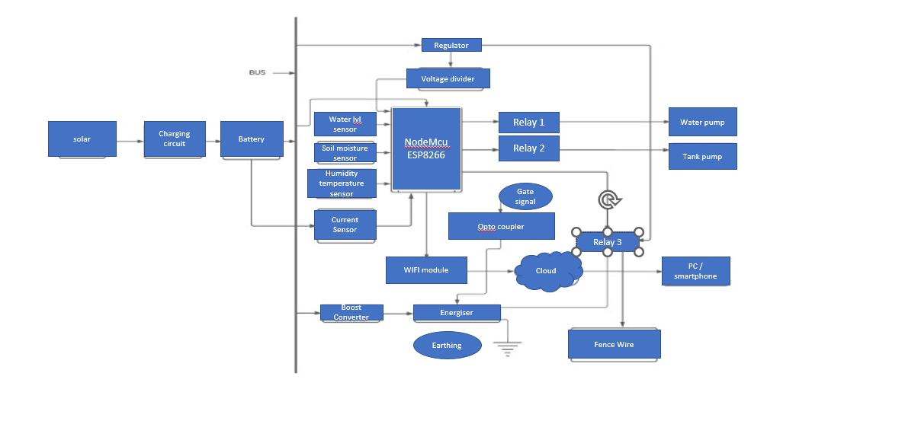

***BLOCK DIAGRAM OF IOT BASED SMART FARMING***

# ALGORITHM / METHODOLOGY:

**STEP 1:** When the temperature of the soil is increased, the temperature sensor will detect the temperature and water is passed to the land.

**STEP 2:** The water is passed to the land by the help of sprinkler, the sprinkler will sprinkle the water to the land. Moisture level- threshold set is between 20% and 60%.

Turn ON at 20%. Turn OFF at 60%.

**STEP 3**: When there any disturbance caused by any living being, the PIR sensor will detect it and intimate the farmer by means of alarm.

**STEP 4**: The plants growth can be monitored by the camera. The camera will send the pic and there is an app implemented in system

,that will detect the plants nutrition level. Nutrition level of nitrogen is 2-10ppm.

Nutrition level of phosphorous is 25-50ppm. Nutrition level of potassium is 40-80 ppm.

**STEP 5**: The moisture level in the soil is detected by the humidity sensor.

**STEP 6**: The water level in the tank is detected by the controller.

**STEP 7**: The water pump will pump the water from ground tank to the surface tank.

**STEP 8**: The farmer will monitor the soil fertility and other activities by means of internet connection with a computer.

**STEP 9**: The water is stored at surface used for the present generation.

**STEP 10**: The water stored at the underground is used for the future use.

**STEP 11**: The overall status can be visualized using Mobile Application.